Project Design Phase-II
Data Flow Diagram & User Stories

Date | 20-02-2026
Team ID | LTVIP2026TMIDS65825
Project Name | FlightFinder
Maximum Marks | 4 Marks

Data Flow Diagrams:
A Data Flow Diagram (DFD) is a traditional visual representation of the information flows within a system. A neat and clear DFD can depict the right amount of the system requirement graphically. It shows how data enters and leaves the system, what changes the information, and where data is stored.

Example: (Simplified)
Example: DFD Level 0 (Industry Standard)

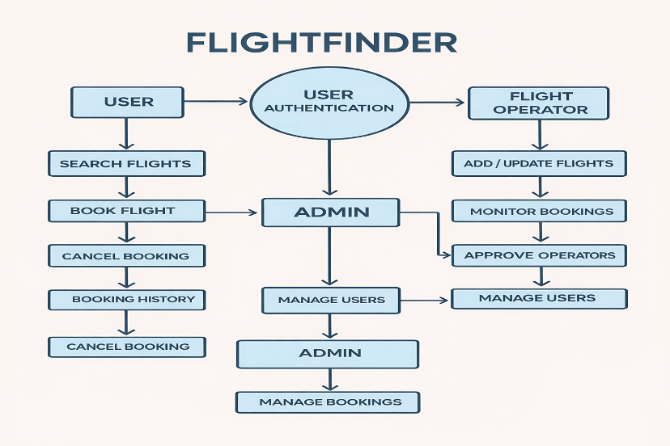

User Stories

User Type | Functional Requirement (Epic) | User Story / Task | Acceptance criteria | Priority | Release
User | User Authentication | As a user, I can register and log in securely. | User credentials are validated and user is redirected to dashboard upon successful login. | High | Sprint-1
User | Password Management | As a user, I can reset or change my password. | Password is updated securely and confirmation is shown. | Medium | Sprint-1
User | Flight Search | As a user, I can search for flights by origin, destination, and date. | Search results return relevant available flights. | High | Sprint-2
User | Flight Filtering | As a user, I can filter flights by class, price, and time. | Filtered results match selected criteria. | Medium | Sprint-2
User | Flight Booking | As a user, I can select a seat and book a flight. | Booking confirmation is generated and seat is allocated successfully. | High | Sprint-3
User | Booking Management | As a user, I can view my booking history. | All previous bookings are displayed correctly. | Medium | Sprint-3
User | Booking Cancellation | As a user, I can cancel a booked flight. | Booking status updates to “Cancelled”. | High | Sprint-3
Admin | Flight Management | As an admin, I can add and update flight details. | Flight details are saved and visible in search results. | High | Sprint-4
Admin | Booking Monitoring | As an admin, I can monitor all bookings. | All bookings are displayed with updated status. | Medium | Sprint-4
Admin | User Management | As an admin, I can approve or reject flight operators. | Approval status updates correctly in the system. | High | Sprint -4

